|  |  |
| --- | --- |
| PROJECT Design  Week 4 Assignment | ABSTRACT  This document was created for UMUC Course, CMSC 495, and analyzes aspects of the (TNC)  Group 3 Members  Name: Christiano, Andrew  Name: Fernandez, Yrume  Name: Orwick, Brian  Name: Sell, Julia  Class: CMSC 495 - Current Trends and Projects in Computer Science Professor: Dr. Hung Dao  Due: 16 September 2018 |

**Version Control**

|  |  |  |  |  |
| --- | --- | --- | --- | --- |
| Revision # | Date | Name | Descriptions | Contact Info |
| TNC_0001 | 9/13/2018 | Brian Orwick | Created | Orwick12@outlook.com |
| TNC_0002 | 9/14/2018 | Yrume Fernandez | Revisions | Yrume.fernandez@gmail.com |
| TNC_0003 | 9/15/2018 | Julia Sell | Revisions | selljm14@gmail.com |
| TNC_0004 | 9/16/2018 | Andrew Christiano | Revisions | ajchristiano91@gmail.com |
|  |  |  |  |  |

**Class Diagram (outside of instantiation of objects)**

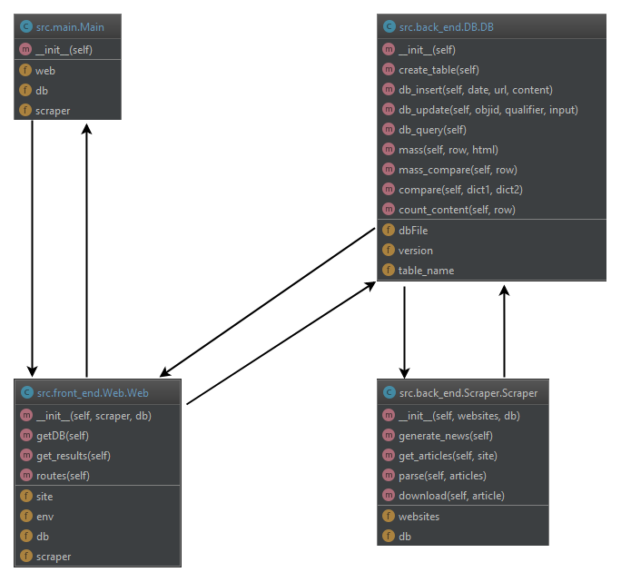

**Sequence diagrams**

**Scenario 1: Start up**

**Description: An administrator runs the TNC program by running main.py with python3.7**

**Precondition: The administrator has a console window up**

**Postcondition: The TNC program is running, waiting for connections from users on port 5000**

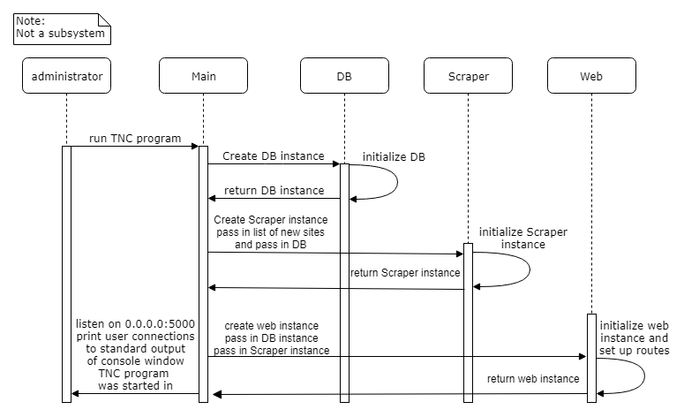

**Scenario 2: Normal user interaction scenario**

**Description: A user navigates to www.tnc.com:5000/**

**Precondition: The administrator is currently running the TNC program**

**Postcondition: The user receives news articles with trustworthiness ratings**

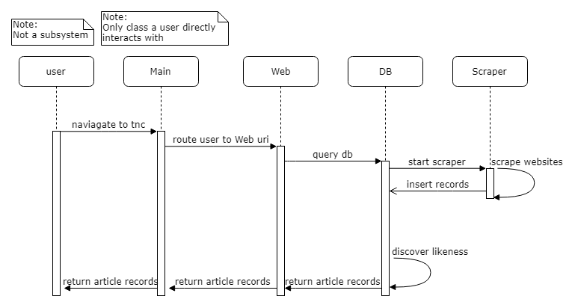

**Scenario 3: User quits early scenario**

**Description: A user navigates to www.tnc.com:5000/ but closes connection prior to receiving results**

**Precondition: The administrator is currently running the TNC program**

**Postcondition: The user does not receive news articles with trustworthiness ratings**

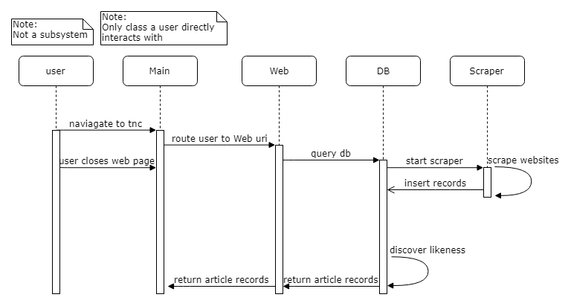

**Scenario 4: Error Scenarios**

**Description: A user navigates to www.tnc.com:5000/ but an error occurs somewhere in the program**

**Precondition: The administrator is currently running the TNC program**

**Postcondition: The user receives a notification to contact the website administrator about the problem**

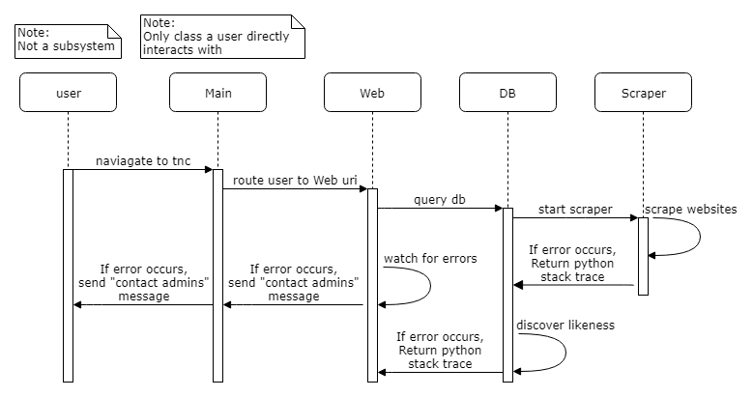

**Scenario 5: Shutdown scenario**

**Description: The administrator closes the TNC program**

**Precondition: The administrator is currently running the TNC program**

**Postcondition: The TNC program is no longer running, and users cannot connect to the service**

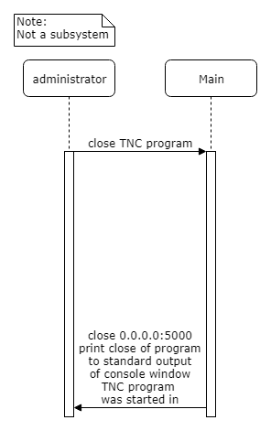

**Pseudocode**

**Main subsystem (runs TNC program, and therefore addresses all requirements):**

class Main(object):

def __init__(self):

instantiate db instance

instantiate scraper instance, passing in list of websites and db instance

instantiate web instance, passing in db and scraper instances

run Main class on port 5000

**DB subsystem (addresses requirements #3, #4, #5, and #7):**

class DB(object):

def __init__(self):

set version to 1

set name of db file

set name of table

run create_table method

def create_table(self):

connect to db

grab a cursor in the db

drop table if exists

commit to db

create table with prepared SQL statement

commit to db

close db connection

def db_insert(self, date, url, content):

connect to db

grab a cursor in the db

insert new entry into table

commit to db

close db connection

def db_update(self, objid, qualifier, input):

connect to db

grab a cursor in the db

update db

commit to db

close connection to db

def db_query(self):

html = ""

connect to db

grab a cursor in the db

select the first entry in the table

fetch row from cursor

close connection to db

compare row to all other entries in db with mass_compare method

pass html and first row to recursive mass method

return html

def mass(self, row, html):

connect to db

try:

grab a cursor in the db

select next entry from db after the row passed into method

fetch row from cursor

if row is None:

close connection to db

return html

close connection to db

html += mass_compare(row)

call mass(row, html) again

except sqlite error:

html = "An error occurred"

close connection to db

return html

def mass_compare(self, row):

connect to db

grab a cursor in the db

select all rows after the row passed into the method

get the row that was passed in

html = ""

while True:

fetch row from cursor

if row is None:

close connection to db

break while loop

compare the likeness of the two rows

if the two rows are very similar:

html += db id's of rows and urls of articles

except sqlite error:

html = "An error occurred"

close connection to db

close connection to db

return html

def compare(self, dict1, dict2):

counter = 0

for key in dict1.keys():

v2 = dict2.get(key)

if v2 is not None:

v1 = float(dict1.get(key))

v2 = float(v2)

v = v2/v1

if v is greater than 90 percent:

counter += 1

percent = float(counter)/float(len(dict1))

return percent

def count_content(self, row):

content = split row using space character as delimiter

return a dictionary object with each of the indices of the content list as

the key, and the amount of times it occurs as the value

**Web subsystem (addresses requirement #6):**

class Web(object):

def __init__(self, scraper, db):

set up instance of Web class

def getDB(self):

populate the database

def get_results(self):

try:

return all results and associations with trustworthiness ratings

except all errors:

return "please contact the administrators"

def routes(self):

define routes for instances of the web class

**Scraper subsystem (addresses requirements #1 and #2):**

class Scraper(object):

def __init__(self, websites, db):

set up instance of Scraper class

def generate_news(self):

for each website passed in:

get the articles using the newspaper3k library

parse the article and insert them into the database

def get_articles(self, site):

use the newspaper3k library to autoscrape a news site

return any articles found

def parse(self, articles):

for each article on a website:

download to retrieve specific contents

insert into the database as a new entry

def download(self, article):

download the article to retrieve the relevant data

return the data as a tuple

**Unresolved Risks and possible mitigation:**

1. The unresolved risk is fake news potentially becoming viral, and unintentionally becomes “trusted” by TNC.
   1. Possible Mitigation: Provide a UI button for users to report “fake news”